39.58: a) Using the given approximation, 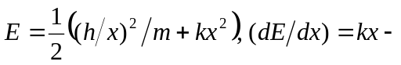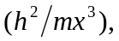 and the minimum energy occurs when 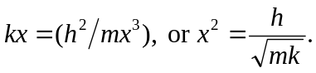 The minimum energy is then 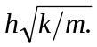
b) They are the same.

